|  |
| --- |
| **National University of Computer and Emerging Sciences** |
| Lab Manual 2  “DML and Data Retrieval ” |
|  |
| Database Systems |
|  |

Department of Computer Science

FAST-NU, Lahore, Pakistan

# Data Modification Language

## Insert rows into table

Syntax

-- let there be N columns in a table

INSERT INTO <tableName>

values

(Column1Value,Column2Value, Column3Value,….,ColumnNValue), --row 1

(Column1Value,Column2Value, Column3Value,….,ColumnNValue), --row2

(Column1Value,Column2Value, Column3Value,….,ColumnNValue) –row 3

Or

INSERT INTO <tableName> (ColumnX,ColumnY) -- List of Columns

values

(ColumnXValue,ColumnYValue), --Row 1 list of Corrrespong column values

(ColumnXValue,ColumnYValue), --Row 2

(ColumnXValue,ColumnYValue) –Row 3

Try the following



Try the following



## To see the data from you table use the following table

Select * from tableName

Try the following and see the results

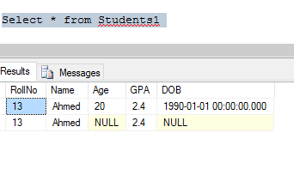

## Updating the rows

Update tableName

set ColumnA=<NewValue>,

ColumnB=<NewValue>,

where <Conditions>

See the data in table before and after trying the following query



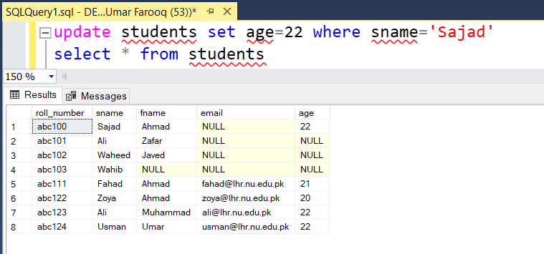

## Update multiple columns

In order to understand the difference, check the above given screenshot.

## Update multiple rows

We can update multiple records using single update command.

# DELETE

## Deleting single record

## Deleting multiple records

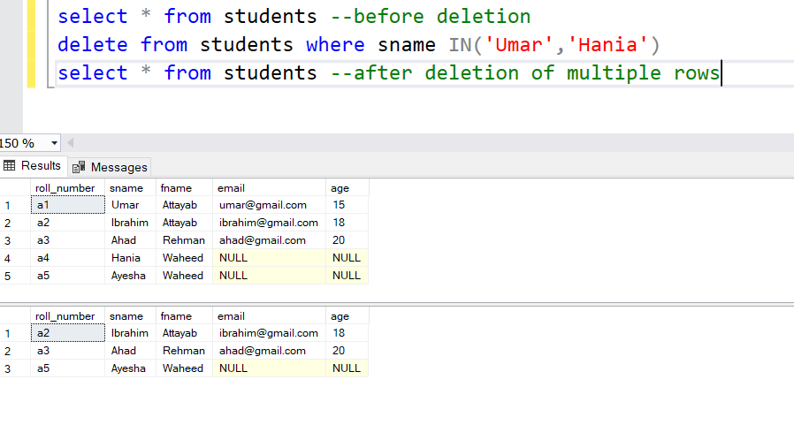

## Deleting all records

It will delete all records from the table.

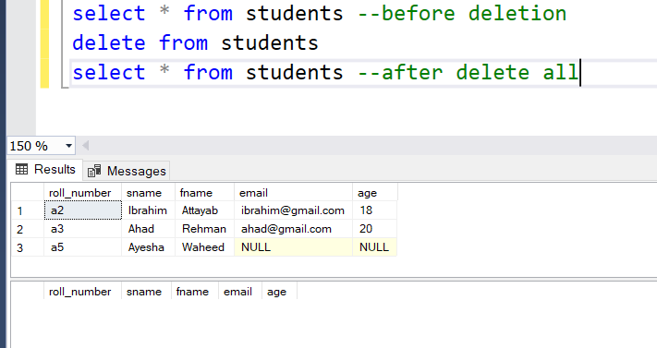

# SELECT

## Select *

Select * selects all records from a table.

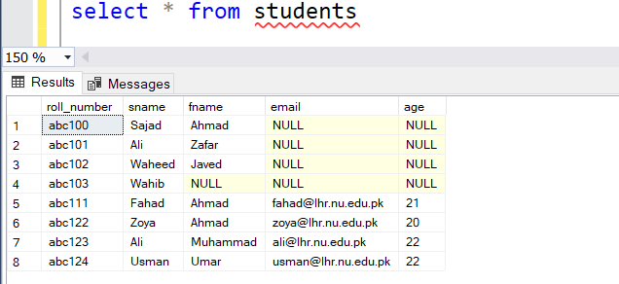

## Select columns

We can specify columns which we want to see from the table. For example:

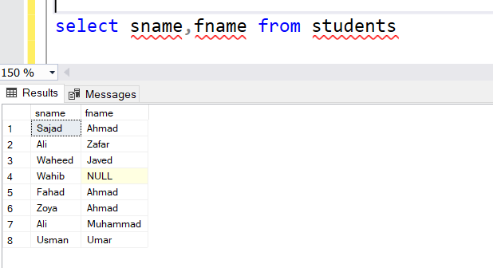

## Select distinct

Distinct command is used to apply filters and extract distinct values. For example in above given screenshot of select *, you can see in age column 2 students Ali and Usman are of the same age , 22. Distinct will show 1 record of age 22.

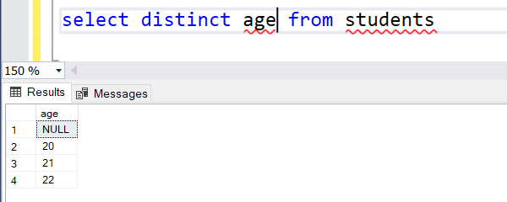

## Select with where clause

With ‘where’ clause we can apply conditions, these conditions help us to find out a specific record of our choice.

We can additionally add ‘and’ and ‘or’ with where as well. For example

## Select with order by clause

Order by clause is used to display data in an orderly way, in numbers it can be ascending or descending. And in alphabetical order as well. Below shared screenshot sname is ordered in an alphabetic manner.

**Syntax:**

SELECT ColumnX as X, ColumnY as Y, ColumnZ

FROM <tableName> as Table1

ORDER BY ColumnX asc/desc, ColumnZ asc/desc

Try this

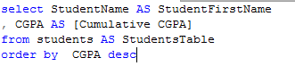

Results

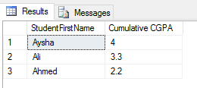

## TOP Clause

Top n clause will give you first n rows from result instead of all the rows.

**Syntax:**

SELECT TOP <n> *

FROM <tableName>

WHERE <conditions>

ORDER BY <column Name> asc/desc

Try this

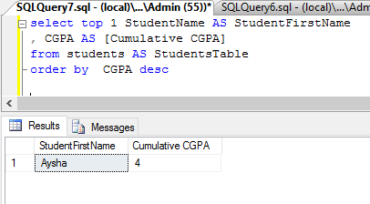

## Select (Relational and Logical Operators)

We can add relational operators and logical operators in select command as below:

where <conditions>

Try this



Results

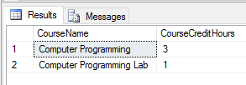

## Like Operator Scenarios

|  |  |
| --- | --- |
| WHERE CourseName LIKE 'C%' | Finds any values that start with "C" |
| WHERE CourseName LIKE '%C' | Finds any values that end with "C" |
| WHERE CourseName LIKE '%Co%' | Finds any values that have "Co" in any position |
| WHERE CourseName LIKE '_r%' | Finds any values that have "r" in the second position |
| WHERE CourseName LIKE 'C_%' | Finds any values that start with "C" and are at least 2 characters in length |
| WHERE CourseName LIKE 'C__% | Finds any values that start with "C" and are at least 3 characters in length |
| WHERE CourseName LIKE 'C%r' | Finds any values that start with "C" and ends with "r" |

**NOTE: %** is referred to as **wildcard**.

# Arithmetic Operations

Sql arithmetic operators are:

* + Addition
* - Subtraction
* / Division
* * Multiplication
* % Modulus

All operations can be performed on either single column or multiple columns

**Syntax:**

1. Apply operation on single columns

SELECT ColumnX, ColumnY + 100

FROM <tableName>

2. Apply operation on multiple columns

SELECT ColumnX, ColumnY + ColumnZ

FROM <tableName>

Replace + with other operators and try them out yourself.

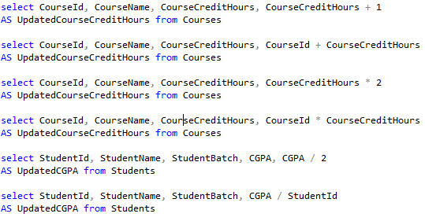

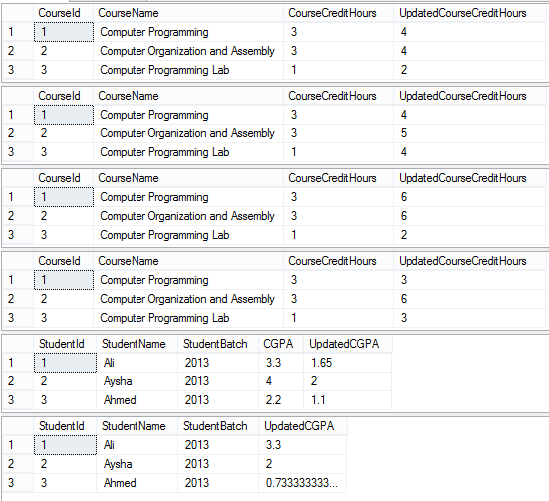

## Renaming Resulting Column

You can rename a column in result by using AS keyword also called Alias. The scope of this renaming is only to that select query, this is useful in joining where more than one table have same column names.

**Syntax:**

SELECT ColumnX as X , ColumnY as Y, ColumnZ

FROM <tableName> as Table1

## **SQL** Server Built-in Functions

Try this



Results

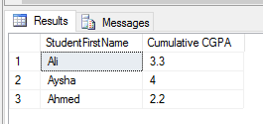

Sql Server has many built-in functions which can be used for different purposes.

For example:

1) GETDATE Returns the current database system date and time

2) CURRENT_TIMESTAMP Returns the current date and time

3) SUBSTRING Extracts some characters from a string

**Syntax:**

1) SELECT GETDATE();

3) SELECT CURRENT_TIMESTAMP;

2) SELECT SUBSTRING(columnName, startposition, substringlength) AS alias FROM <tableName>;

Try to explore as many string and data functions through this link: https://www.w3schools.com/sql/sql_ref_sqlserver.asp